**Cloudwatch logs Assiignment - 1**

**Create a lambda function to start, stop and terminate a running EC2 instance. Also, verify the logs generated by the lambda in the Cloudwatch logs to check whether the lambda execution is done properly.**

1. Create an EC2 Instance

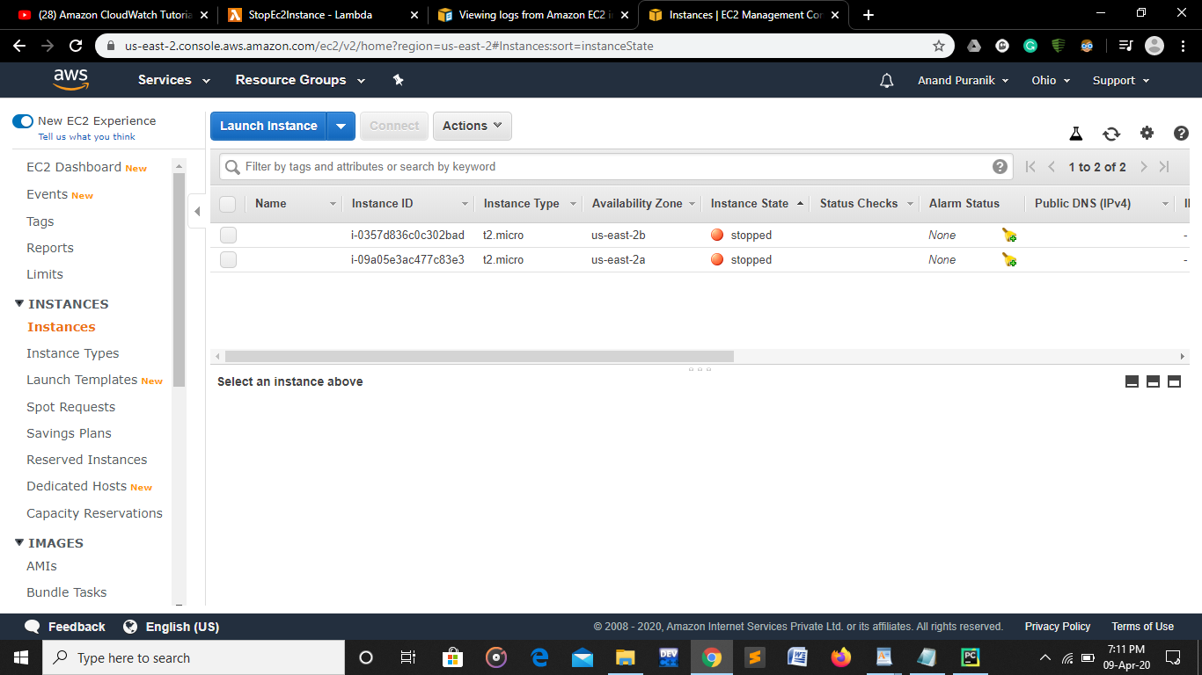

1. Create Two Lambda Functions to Start and Stop EC2 instance.

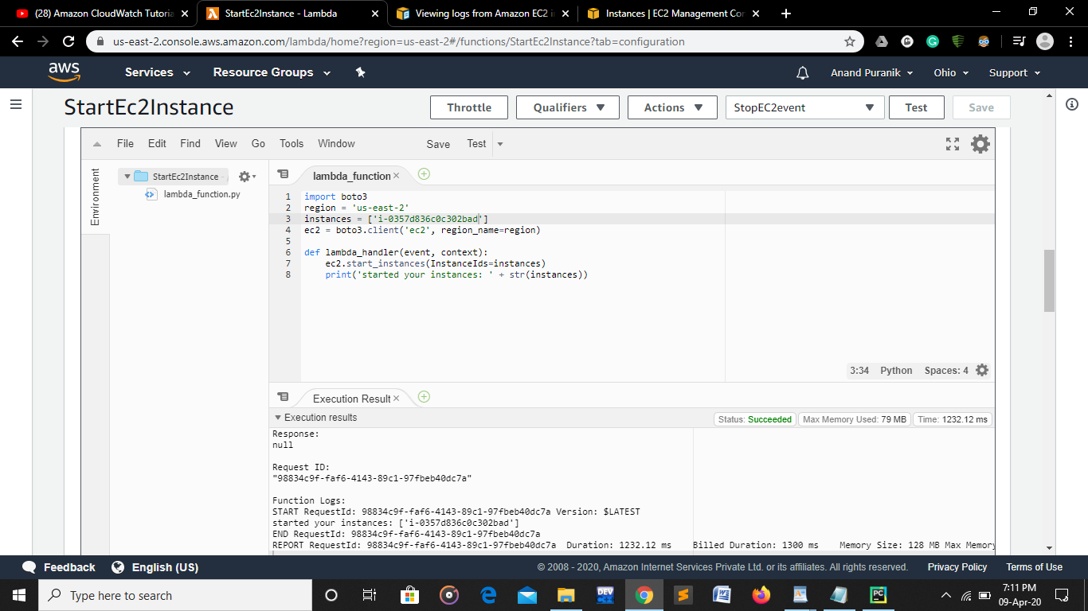

1. The Ec2 instance is initiated after running start function of lambda

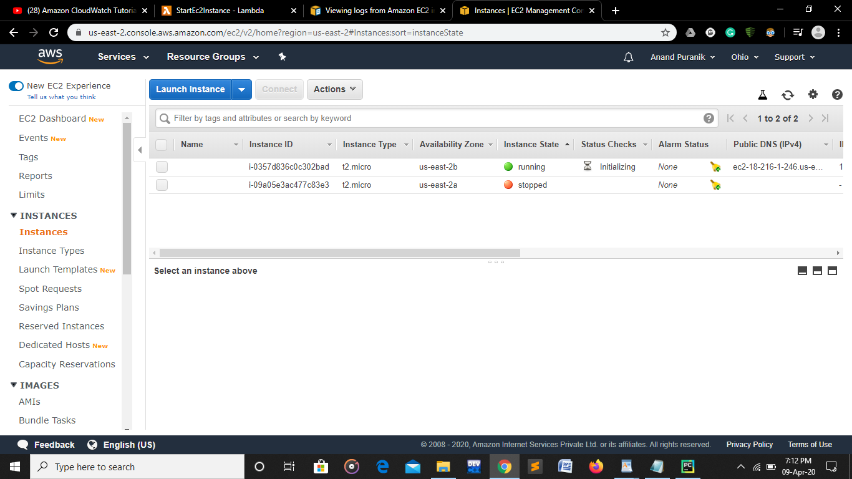

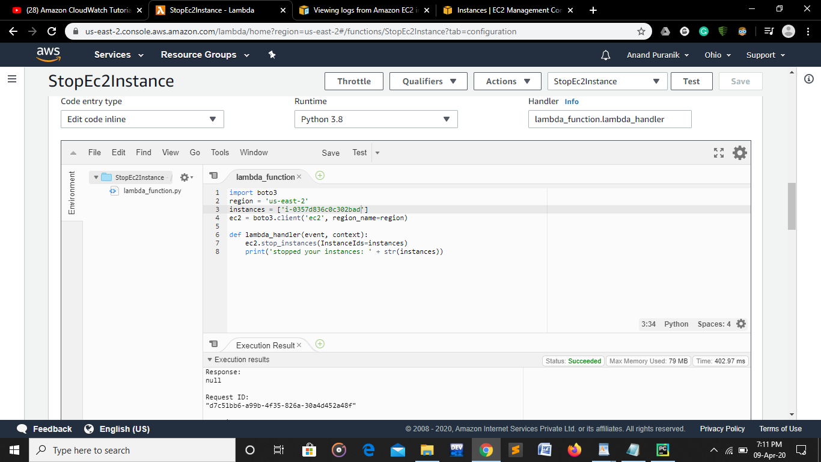

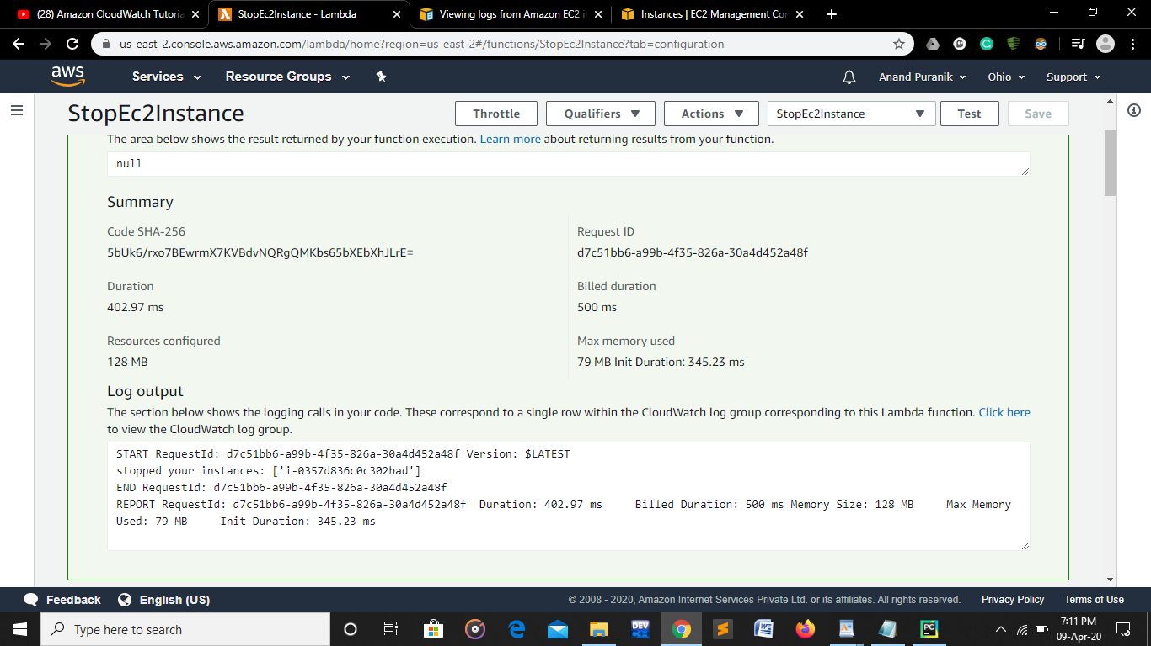

Ec2 instance is topped



* Start Stop function Lambda
* start
* import boto3  
  region = 'us-east-2'  
  instances = ['i-0357d836c0c302bad']  
  ec2 = boto3.client('ec2', region_name=region)  
    
  def lambda_handler(event, context):  
      ec2.start_instances(InstanceIds=instances)  
      print('started your instances: ' + str(instances))
* stop

import boto3  
region = 'us-east-2'  
instances = ['i-0357d836c0c302bad']  
ec2 = boto3.client('ec2', region_name=region)  
  
def lambda_handler(event, context):  
    ec2.stop_instances(InstanceIds=instances)  
    print('stopped your instances: ' + str(instances))

**Assignment #3- Create a lambda function to send an email notification to your email id of your AWS account, as soon as you delete a file from an S3 bucket, mentioning the file name which is deleted.**

1. Create a role and attach lambda function to it.

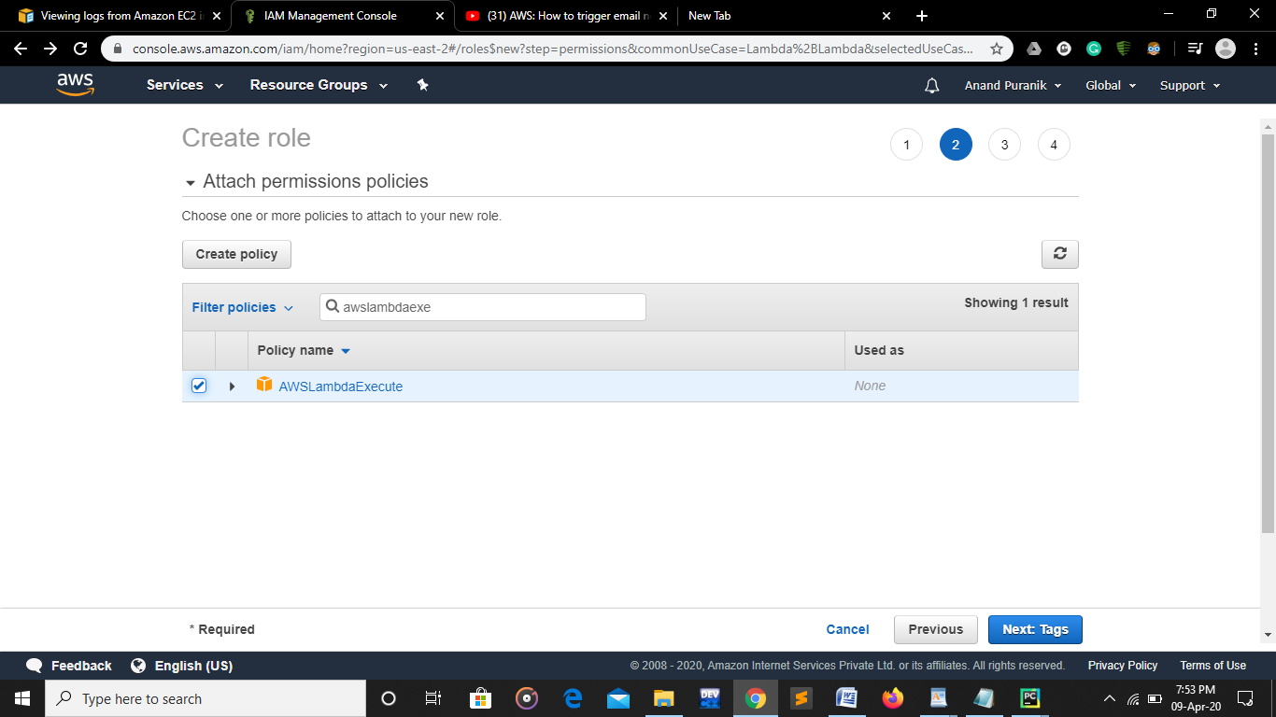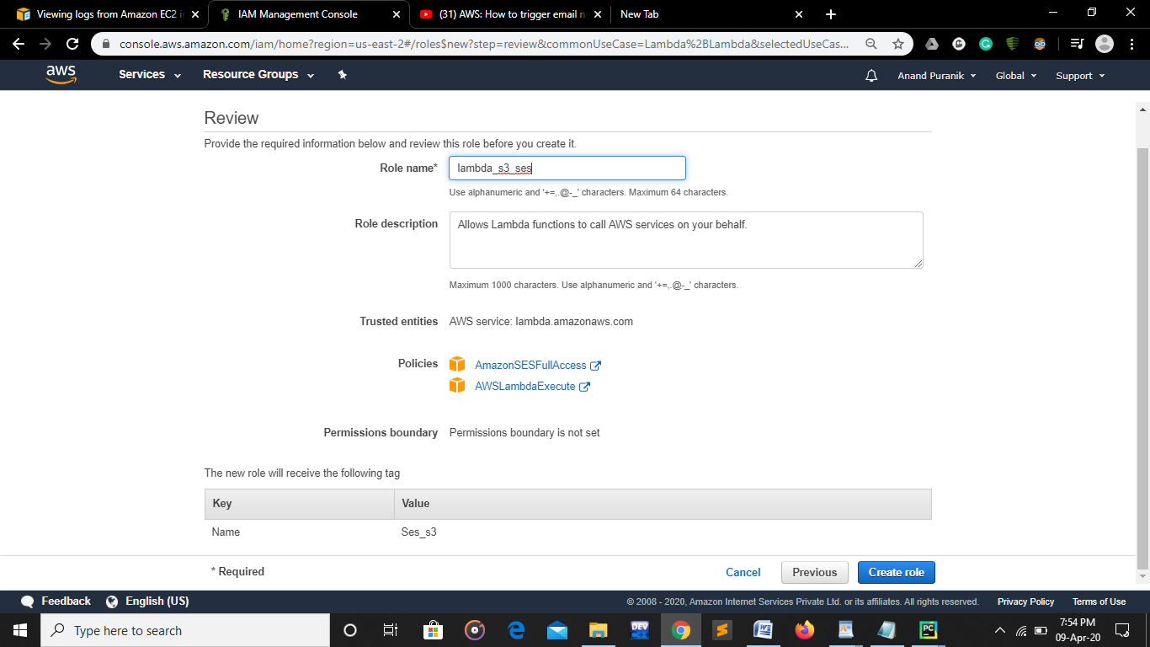

A role is created

1. Choose a bucket -> Goto Properties -> Advance settings and choose Events

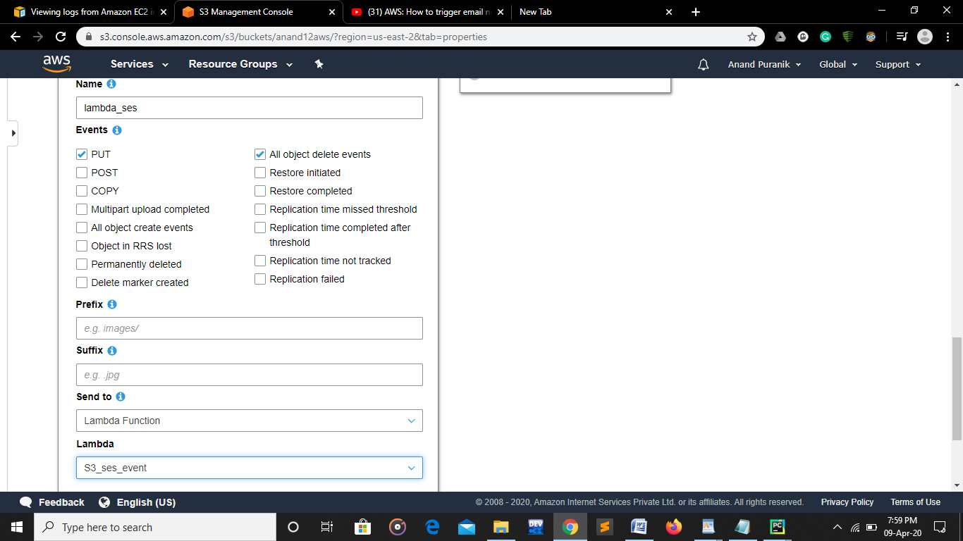

**In** events choose

Events- PUT

All objects delete event

Attach lambda event

then go to lamda function and write the access code for the notifying mail for deleting any files from the s3 bucket:

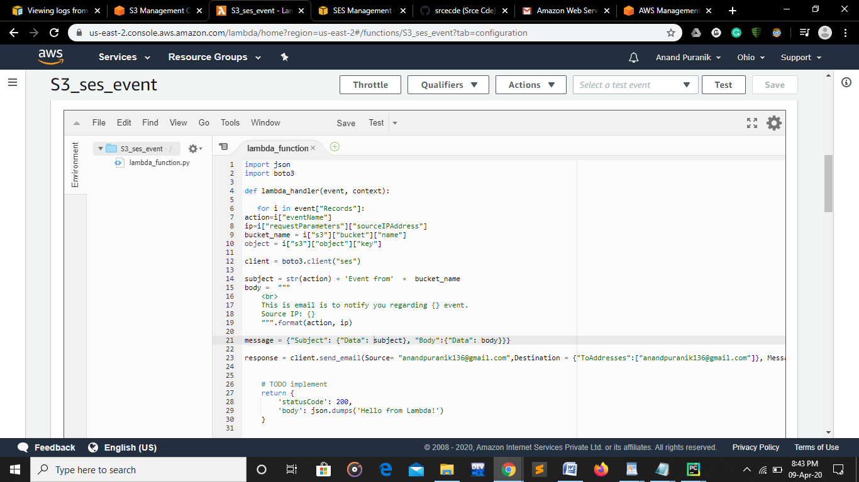

**Now save the code and test it by deleting any element from s3 storage and check for clouwatch logs to check execution of code**

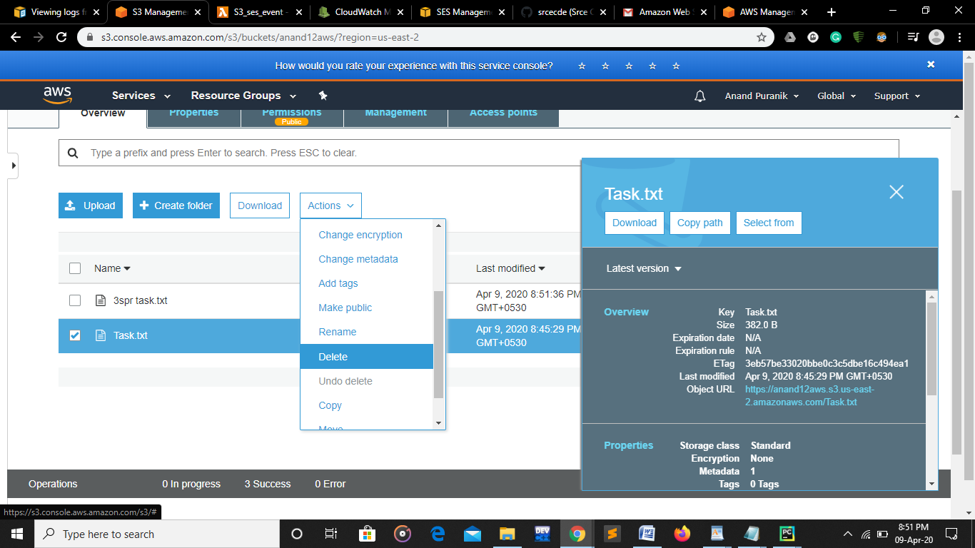

go to simple email service to verify the email

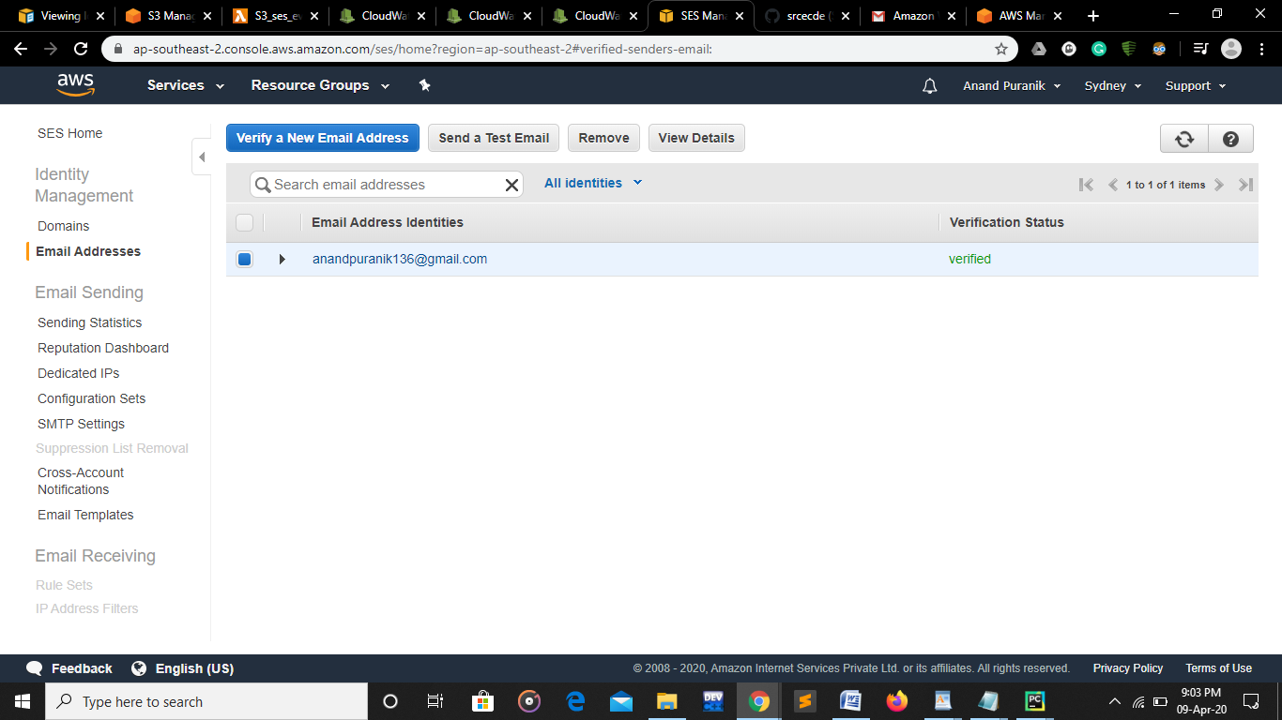

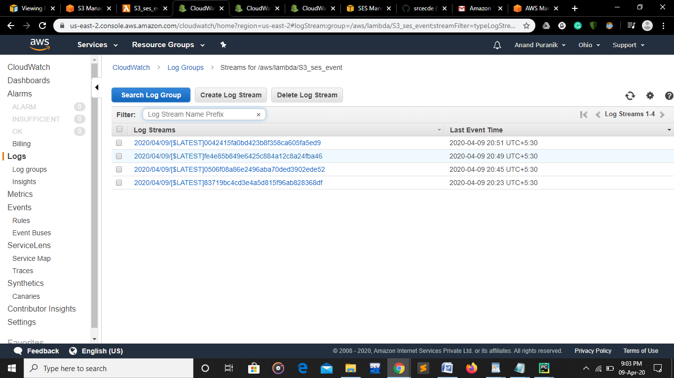

then go to cloudwatch and check whether deleting notification is accessing or not